ELECTRON TRANSPORT CHAIN
The electron transport chain is a series of proteins and organic molecules found in the inner membrane of the mitochondria. Electrons are passed from one member of the transport chain to another in a series of redox reactions. Energy released in these reactions is captured as a proton gradient, which is then used to make ATP in a process called chemiosmosis. Together, the electron transport chain and chemiosmosis make up oxidative phosphorylation.
The key steps of this process include:
- Delivery of electrons by NADH and FADH₂. Reduced electron carriers (NADH and FADH₂) from other steps of cellular respiration transfer their electrons to molecules near the beginning of the transport chain. In the process, they turn back into NAD⁺ and FAD, which can be reused in other steps of cellular respiration.
- Electron transfer and proton pumping. As electrons are passed down the chain, they move from a higher to a lower energy level, releasing energy. Some of the energy is used to pump H⁺ ions, moving them out of the matrix and into the inter-membrane space. This pumping establishes an electrochemical gradient.
- Splitting of oxygen to form water. At the end of the electron transport chain, electrons are transferred to molecular oxygen, which splits in half and takes up H⁺ to form water.
- Gradient-driven synthesis of ATP. As H⁺ ions flow down their gradient and back into the matrix, they pass through an enzyme called ATP synthase, which harnesses the flow of protons to synthesize ATP.
We'll look more closely at both the electron transport chain and chemiosmosis in the sections below.

The electron transport chain
The electron transport chain is a collection of membrane-embedded proteins and organic molecules, most of them organized into four large complexes labeled I to IV. In eukaryotes, many copies of these molecules are found in the inner mitochondrial membrane. In prokaryotes, the electron transport chain components are found in the plasma membrane.
As the electrons travel through the chain, they go from a higher to a lower energy level, moving from less electron-hungry to more electron-hungry molecules. Energy is released in these “downhill” electron transfers, and several of the protein complexes use the released energy to pump protons from the mitochondrial matrix to the inter-membrane space, forming a proton gradient.
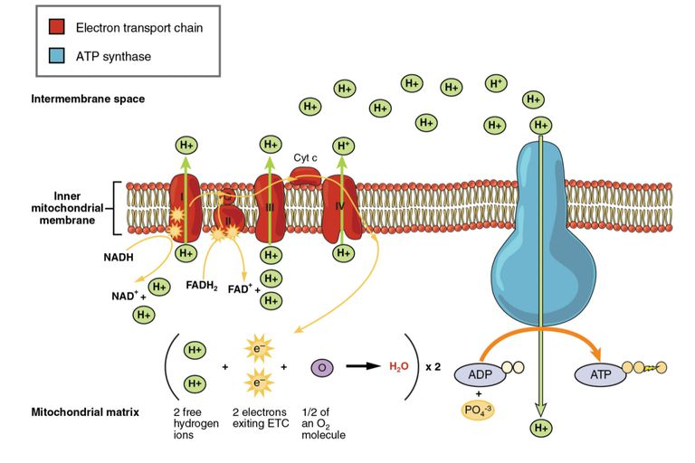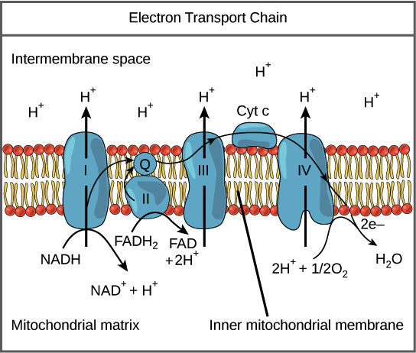
All of the electrons that enter the transport chain come from NADH and FADH₂​ molecules produced during earlier stages of cellular respiration: glycolysis, pyruvate oxidation, and the citric acid cycle.
- NADH is very good at donating electrons in redox reactions (that is, its electrons are at a high energy level), so it can transfer its electrons directly to complex I, turning back into NAD⁺. As electrons move through complex I in a series of redox reactions, energy is released, and the complex uses this energy to pump protons from the matrix into the inter-membrane space.
- FADH₂ is not as good at donating electrons as NADH (that is, its electrons are at a lower energy level), so it cannot transfer its electrons to complex I. Instead, it feeds them into the transport chain through complex II, which does not pump protons across the membrane.
Because of this "bypass," each FADH₂ molecule causes fewer protons to be pumped (and contributes less to the proton gradient) than an NADH.
Beyond the first two complexes, electrons from NADH and FADH₂ ​travel exactly the same route. Both complex I and complex II pass their electrons to a small, mobile electron carrier called ubiquinone (Q), which is reduced to form QH₂​ and travels through the membrane, delivering the electrons to complex III. As electrons move through complex III, more H^++ ions are pumped across the membrane, and the electrons are ultimately delivered to another mobile carrier called cytochrome C (cyt C). Cyt C carries the electrons to complex IV, where a final batch of H⁺ ions is pumped across the membrane. Complex IV passes the electrons to O₂​, which splits into two oxygen atoms and accepts protons from the matrix to form water. Four electrons are required to reduce each molecule of O₂​, and two water molecules are formed in the process.
Overall, what does the electron transport chain do for the cell? It has two important functions:
- Regenerates electron carriers. NADH and FADH₂​ pass their electrons to the electron transport chain, turning back into NAD⁺ and FAD. This is important because the oxidized forms of these electron carriers are used in glycolysis and the citric acid cycle and must be available to keep these processes running.
- Makes a proton gradient. The transport chain builds a proton gradient across the inner mitochondrial membrane, with a higher concentration of H⁺ in the intermembrane space and a lower concentration in the matrix. This gradient represents a stored form of energy, and, as we’ll see, it can be used to make ATP.

Chemiosmosis
Complexes I, III, and IV of the electron transport chain are proton pumps. As electrons move energetically downhill, the complexes capture the released energy and use it to pump H⁺ ions from the matrix to the inter-membrane space. This pumping forms an electrochemical gradient across the inner mitochondrial membrane. The gradient is sometimes called the proton-motive force, and you can think of it as a form of stored energy, kind of like a battery.
Like many other ions, protons can't pass directly through the phospholipid bilayer of the membrane because its core is too hydrophobic. Instead, H⁺ ions can move down their concentration gradient only with the help of channel proteins that form hydrophilic tunnels across the membrane.
In the inner mitochondrial membrane, H⁺ ions have just one channel available: a membrane-spanning protein known as ATP synthase. Conceptually, ATP synthase is a lot like a turbine in a hydroelectric power plant. Instead of being turned by water, it’s turned by the flow of H⁺ ions moving down their electrochemical gradient. As ATP synthase turns, it catalyzes the addition of a phosphate to ADP, capturing energy from the proton gradient as ATP.
This process, in which energy from a proton gradient is used to make ATP, is called chemiosmosis. More broadly, chemiosmosis can refer to any process in which energy stored in a proton gradient is used to do work. Although chemiosmosis accounts for over 80% of ATP made during glucose breakdown in cellular respiration, it’s not unique to cellular respiration. For instance, chemiosmosis is also involved in the light reactions of photosynthesis.
What would happen to the energy stored in the proton gradient if it weren't used to synthesize ATP or do other cellular work? It would be released as heat, and interestingly enough, some types of cells deliberately use the proton gradient for heat generation rather than ATP synthesis. This might seem wasteful, but it's an important strategy for animals that need to keep warm. For instance, hibernating mammals (such as bears) have specialized cells known as brown fat cells. In the brown fat cells, uncoupling proteins are produced and inserted into the inner mitochondrial membrane. These proteins are simply channels that allow protons to pass from the inter-membrane space to the matrix without traveling through ATP synthase. By providing an alternate route for protons to flow back into the matrix, the uncoupling proteins allow the energy of the gradient to be dissipated as heat.
In bacteria, both glycolysis and the citric acid cycle happen in the cytosol, so no shuttle is needed and 5 ATP are produced.
30-32 ATP from the breakdown of one glucose molecule is a high-end estimate, and the real yield may be lower. For instance, some intermediates from cellular respiration may be siphoned off by the cell and used in other biosynthetic pathways, reducing the number of ATP produced. Cellular respiration is a nexus for many different metabolic pathways in the cell, forming a network that’s larger than the glucose breakdown pathways alone.
- Complex I (NADH dehydrogenase)
Contains FMN, which accepts 2 electrons and H + from 2 NADH to become the reduced form of FMNH₂ ; also contains iron atoms, which assist in the transfer of the e − and H + to coenzyme Q.
- Complex II (Succinate dehydrogenase)
Contains iron and succinate, which oxidizes FADH₂ to form FAD
- Coenzyme Q
Accepts electrons from FMNH₂ (complex I) and FADH₂ (complex II) and transfers electrons to complex III.
- Complex III (cytochrome b)
Contains heme group, in which the Fe 3+ accepts the electrons from coenzyme Q to become Fe 2+. Transfers electrons to cytochrome c.
- Cytochrome c
Contains heme group, in which the Fe 3+ accepts the electrons from complex III to become Fe 2+. Transfers electrons to complex IV.
- Complex IV (cytochrome a)
Contains heme group, in which the Fe 3+ accepts electrons from cytochrome c to become Fe 2+. Transfers electrons to O₂, which is combined with hydrogen to form H₂O.
- Complex V (ATP synthase)
Contains a proton channel that allows for protons to cross into the matrix, using the proton gradient energy to form ATP.

